VOLUME OF A PRISM
Pearson Edexcel - Thursday 4 June 2020 - Paper 2 (Calculator) Foundation Tier

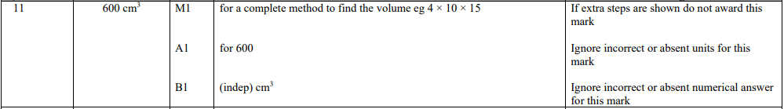

Pearson Edexcel - Monday 8 June 2020 - Paper 3 (Calculator) Foundation Tier

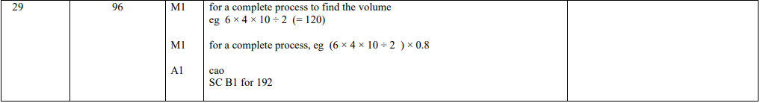

Pearson Edexcel - Thursday 7 June 2018 - Paper 2 (Calculator) Foundation Tier

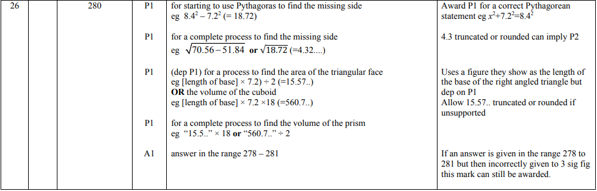

Pearson Edexcel - Thursday 2 November 2017 - Paper 1 (Non-Calculator) Foundation Tier

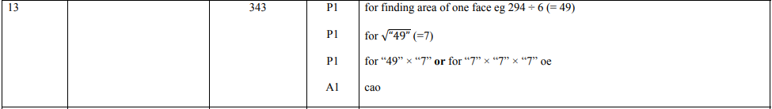

Pearson Edexcel - Wednesday 8 November 2017 - Paper 3 (Calculator) Foundation Tier

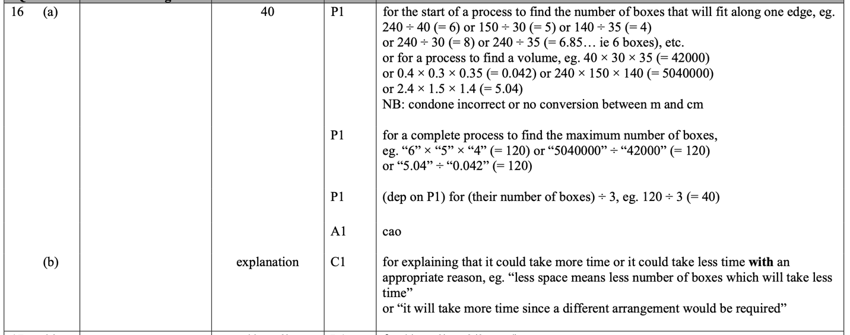

Pearson Edexcel – Specimen 2 - Paper 3 (Calculator) Foundation Tier

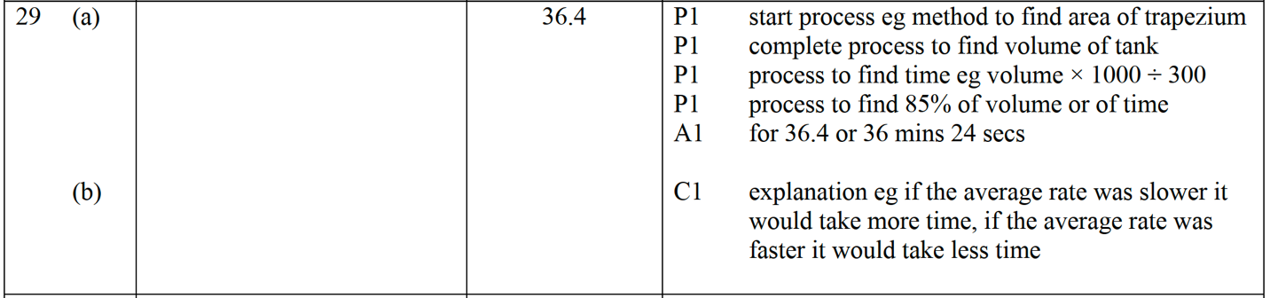

Pearson Edexcel – Specimen 1 - Paper 1 (Non-Calculator) Foundation Tier

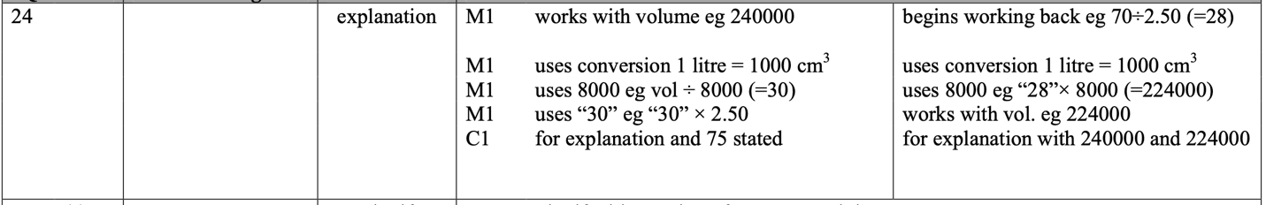

OCR – Tuesday 03 November 2020- Morning - Paper 1 (Calculator) Foundation Tier

OCR November 09 November 2020- Morning (Calculator) Foundation Tier
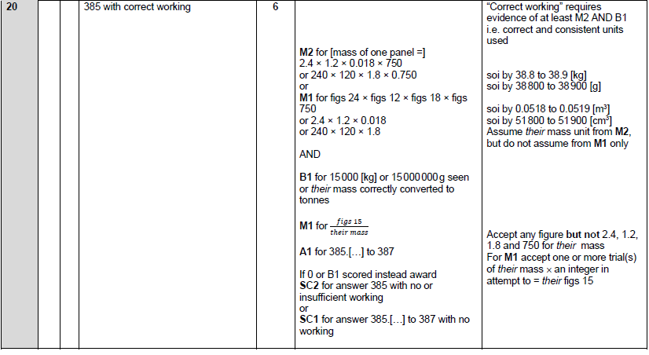

OCR Tuesday 5 November 2019 – Morning (Calculator) Foundation Tier
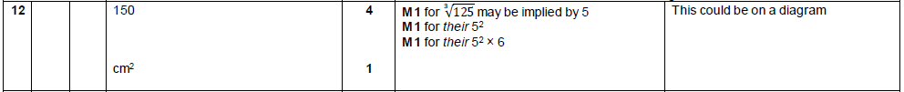

OCR Wednesday 8 November 2017– Morning (Calculator) Foundation Tier

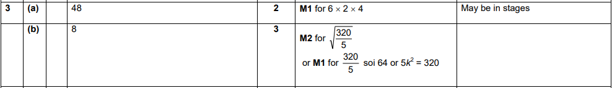

AQA Monday 6 November 2017 – Morning (Calculator) Foundation Tier

